Ignacio White Eagle
October 22, 1951 – October 9, 2007

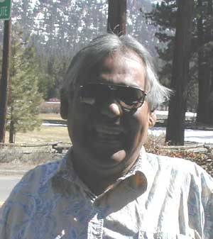

His songs are sung
His paintings done
He leaves us now
on the setting sun

Ignacio Gregorio Rodriguez White Eagle was born October 22, 1951 and died as the sun set on October 9, 2007 leaving behind his heart son Mikey, two brothers, three sisters and many friends. Ignacio shared his light in Lake Tahoe, Hawaii, and Tuolumne where he brighten everyone he met with spontaneous song, contagious laughter and a genuine heart. Ignacio will be immortalized by his distinctive and detailed rendering of Native American art. His paintings are remarkable for their depth and emotional impact. He will be missed, but in his own words, "He is now soaring on the wings of an Eagle."
Ignacio was an enrolled Gros Ventre Native American Indian from the Fort Belknap Indian Reservation in Montana. He studied art in California at Hartnell Junior College, University of California, Berkeley, South Lake Tahoe Community College and Thomas Leighton Art Academy in San Francisco, California. He specialized in Native American portraits, usually in charcoal and water color. Ignacio was the art instructor at Bijou Community School in South Lake Tahoe, California for five years, and he has taught art at Diamond Valley Elementary School in Woodfords, California. He has taught art at the Washoe Indian Colony in Alpine County. He last resided in Tuolumne, California.
Ignacio began his professional art career in the mid 70's and his extensive work of Native American portraits currently hang in private collections throughout the United States, Hawaii and in England.
A memorial service will be held in Hana, Maui, Hawaii in February, 2008. For more information call 530-577-7293. A support fund has been set up for Ignacio’s 11 year old guardian son, Mikey Ahumada. To contribute towards Mikey’s care and education, contact any U.S. Bank or send check to U.S.Bank, 406 North Main Street, Sebastopol, CA 95472 in care of account # 2534-5369-7695.
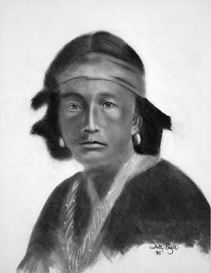
To view Ignacio’s Native American drawings,
http://www.ignaciowhiteeagle.com

